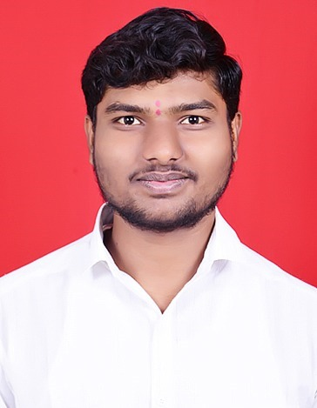**RESUME**

**Sachin Sadashiv Shinde**

* **PERSONAL INFORMATION** :

• Email – sachinshinde@gmail.com

• Contact - 9146313028

• Address - Taloja , NaviMumbai.

1. Date of Birth – 30th April, 2003

2. Marital Status - Unmarried

3. Languages known - English, Hindi, Marathi.

* **OBJECTIVE:**

My goal is to work productively and contribute to a respected organization in the field of Artificial Intelligence and Data Science Engineering, while fostering both personal growth and the achievement of the company's objectives.

* **EDUCATIONAL QUALIFICATION**:

Bachelor of Science in Artificial Intelligence and Data Science

Mumbai University , Kharghar,Maharashtra

[November 2022] – [June 2026]

Relevant coursework: Data Structures, Algorithms, Database Systems, Software Engineering

* **EXTRA-CURRICULAR ACTIVITIES:**

1.Worked in an TPO committee.

2.Worked in CSI Committee.

3. Completed programming course on coursera about C, C++, JAVA,PHP,MYSQL and Python.

* **PROJECTS:**

1. BRAINUP APP .

2. PLANT DISEASE DETECTION.

* **SKILLS :**

1. Good communication skills.

2. Good presentation skills.

3. A quick learner.

* **HOBBIES:**

1.Participating in Coding Feast.

2. Reading Novels.

* **DECLARATION :**

I hereby declare that the above-mentioned information is genuine and true to the best of my knowledge.

Place:Taloja,Navimumbai.

Date:21 September,2024.

Sachin S.Shinde